MRS Overhead View ( OVHV ) Help

Paul Shcherbakov

Maria Diattchina

Updated January 12, 2009

Contents:

Lanes 2

Skids in Lanes 2

Lane Handle 2

Lane Menu 2

Skids 3

Product Code and Bundle Count 3

Edit Skid Dialog 3

Adding a Skid to a Lane 4

AGVs 4

AGVs 3 color scheme 5

AGV Status 5

AGV Menu 6

AGV Alert States 6

Alert Message 7

Changing AGV destination 8

Useful AGV Tips 8

Machines 8

Moving cursor over Machine Image 8

Automation Level 9

Active Product 9

Product for Pick Up 9

Useful Machine Tips 10

Machine Menu 11

Edit WO dialog 11

Doors 12

Loading Trucks 12

Door Menu 12

Load Info 12

Clusters 13

Cluster tag 13

Cluster Info 13

Cluster Menu 14

Editing Cluster 14

Adding New Cluster 15

Adding Lane To Cluster 16

Setting Visual Product Attributes 16

Selecting Products 16

Using Current Products Only checkbox 16

Removing Selected Product Labels 17

Tracking Old Products 17

Adding Products to Product Combo 18

Refresh the Screen button 18

# Lanes

## Skids in Lanes:

Lanes show skids collections in real-time. Each **Skid** by default represented by a black square. Skids are placed proportionally to lane load capacity, so the MR can visually extrapolate what the lane capacity is.

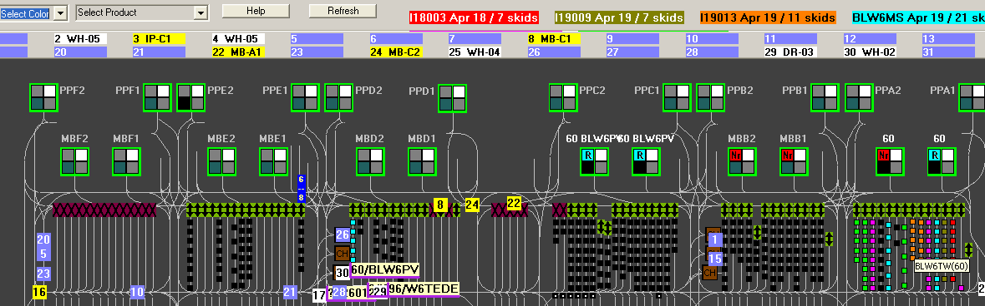

One can assign a color to a product – this will paint all the product **Skids** on the floor with the same color.

The color label on the top of the screen also provides a count of all the product skids.

## Lane Handle:

**Lane Handle** located at the end of the lane, and features either **Enabled** or **Disabled** lane icon.



Moving a cursor over a **Lane Handle** will show the Lane Name and Lane ID.



**Selected Lane information** is available by double-clicking on a **Lane Handle**:



## Lane Menu:

Right click on the **Lane Handle** brings up context sensitive menu for the Lane.

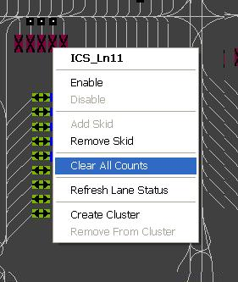

These menu choices allow single click **Enable/Disable** lane functionality, plus the ability where applicable to **Add** or **Delete** a load.

# Skids

## Product Code and Bundle Count:

Moving cursor over a **Skid** will show Product Code and Bundle Count.

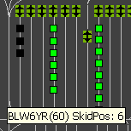 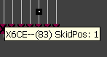

Head Skids identified by the dot inside of the Skid image.

## Edit Skid Dialog:

Right clicking on a **Skid** brings up an **Edit Skid dialog** where Skids’ Product Code along with its’ Bundle Count can be edited from.

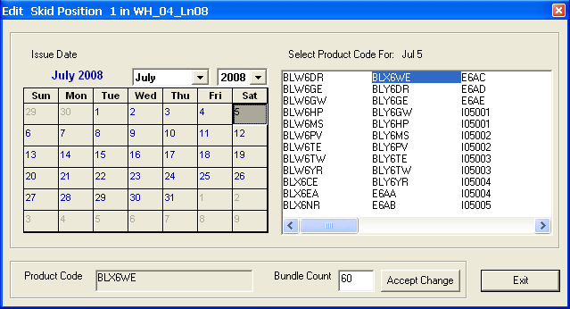

## Adding a Skid to a Lane:

A similar dialog is provided when MR wants to **Add** a **Skid** to a **Lane**:

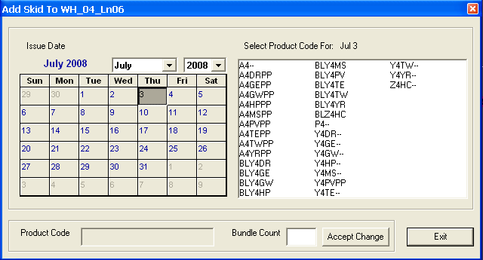

# AGVs

## AGVs 3 color scheme:

**Light Purple** color indicates that an **AGV** has no current job;

**Yellow** means that an **AGV** has a job and going to pick up a load;

**White** means that an **AGV** loaded and is heading to its’ drop position

**Orange** means that an **AGV** is charging or going to be charging.

 Loaded **AGV**s drag a tag combining **BundleCount** and **ProductCode**.

If you see a “**?**” in **BundleCount** space, it means that OVHV has no info on the **Bundle Count** yet.

## AGV Status:

Each **AGV** has a **Box** at the top of the screen showing its’ status, and next destination, if applicable



*Below there are a few samples describing various* ***AGV*** *states.*

  Here AGV 5 is loaded but will requires a charge.

  Here AGV 12 moving to Pick Up a load.

  Here AGV 10 is loaded and delivering OK.

  Here AGV 3 is charging.

**Double Clicking on AGV Box** will magnify the **AGV** and will show an arrow to the next position if **AGV** has a destination.

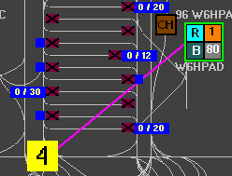

## AGV Menu:

**Left clicking on AGV Box** brings up an up context sensitive menu for the **AGV**.

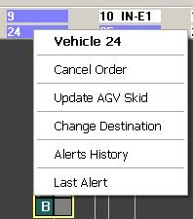

## AGV Alert States:

If **AGV** changed color to Red, Magenta, Green, Brown or Dark Purple you can check the **history of the AGV** to identify **AGV** issues.

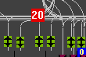 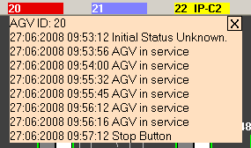



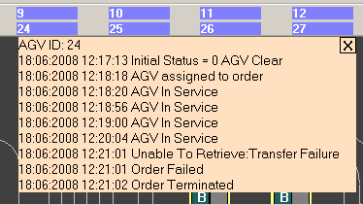

## Alert Message:

**Alert Message** pops up next to **AGV** to display any serious issues with it.

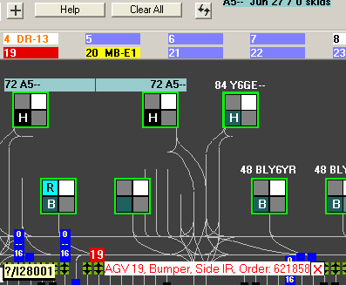

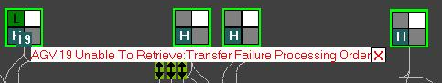

## Changing AGV destination:

You can **change AGV destination** by clicking “Change Destination” menu item.

The dialog whit all available destinations will show up.

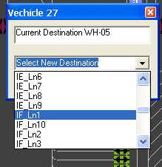

## Useful AGV Tips:

1. To change Order destination you can simply Drag And Drop **AGV Box** to a **Lane Handle**.

2. You can generate **New Order** by Dragging And Dropping any **Skid** directly to a **Lane Handle**.

# Machines

## Moving cursor over Machine Image:

**Machines** (PressPaletizer, InserterPaletizer, ManualBailout) are represented by an image similar to the one below.

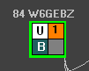

Moving cursor over any quadrant will show an explanation for the current depiction.

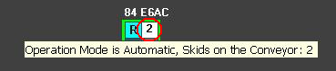 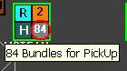

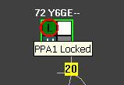 

## Automation Level:

Green or Yellow frame around **Machine** represents **Automation Level** for this **Machine**.

Green means Automation is ON.

Yellow means Automation is Off.

## Active Product:

Label at the top of the machine represents **Active Product** for **Machine**

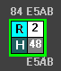

## Product for Pick Up:

Label at the bottom of the **Machine** represents **Product** on the **Pick Up Position**.

## Useful Machine Tips:

Use this Legend to familiarize yourself with **Machine** states. The Legend is available by pressing **Help button**.

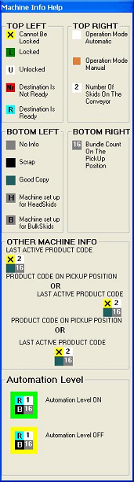

## Machine Menu:

Right Click on any quadrant in **Machine** will bring up a context sensitive menu for the **Machine**.

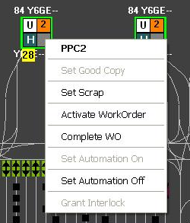

## Edit WO dialog:

Pressing Activate WorkOrder menu item will pop up the Edit WO dialog. You can select any available WO and activate it on the **Machine**.

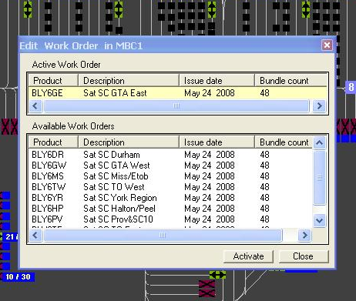

# Doors

## Loading Trucks:

**Doors** display Loading Truck names on Purple background. Doors without display **Door** name on grey background.

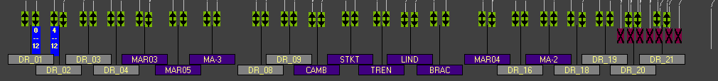

## Door Menu:

Right click on the **Door** image brings up context sensitive menu for the door.

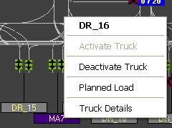

Note: Activate/Deactivate truck functions are not yet implemented.

## Load Info:

**Planned Load** info is available by double clicking on the **Door**.

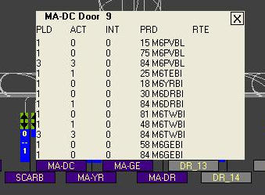

# Clusters

## Cluster tag:

**Clusters** are shown as blue rectangles (**Cluster Tag**) attached to some **Lane Handles**. Since a **Cluster** can span a number of Lanes, only one **Lane** of each **Cluster** has a longer tag, which has total of planned and delivered counts displayed.



To learn which lanes belong to ‘this’ **Cluster** click on any **Cluster Tag**, then all the **Cluster Tags** belonging to this **Cluster** are highlighted – shown with lighter blue color.

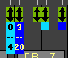

## Cluster Info:

Moving cursor over **Cluster Tag** will show Lane Name, Cluster ID, total of planned and total of delivered counts



Double-Clicking on any **Cluster Tag** will display the **Cluster** info for a few seconds:

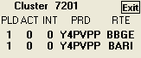

When an **AGV** delivers to a **Lane** which belongs to a **Cluster** a PopUp as above is also shown for a few seconds –just to confirm the counts for the delivery.

## Cluster Menu:

Right click on the **Cluster Tag** opens up the **Cluster** context menu. The Menu allows users to **Edit** or **Remove** a **cluster**.

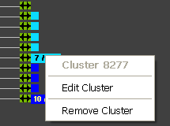

## Editing Cluster:

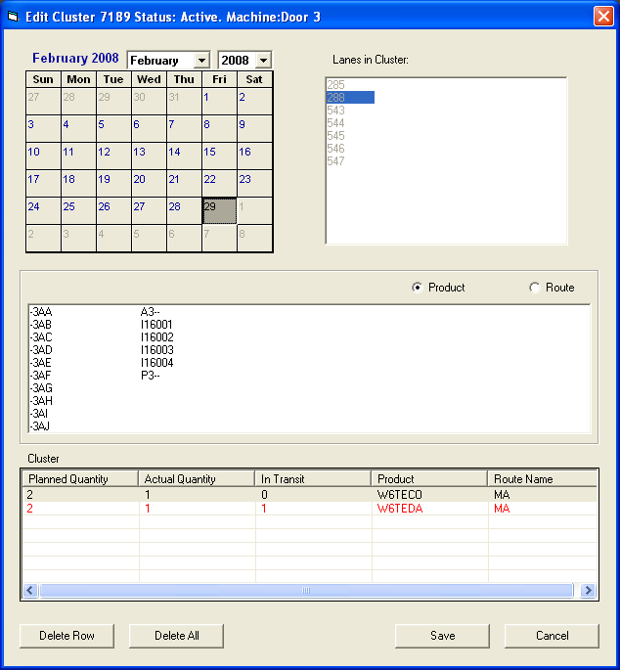

Just update **Products** and/or **Routes**, and **Skid Counts** as needed, and press **Save** button.

## Adding New Cluster:

To Add a New Cluster, select Create Cluster from Lane Handle menu:

Then highlight all desired Lanes, select Products and/or Routes, enter Skid Counts as needed, and press Save button.

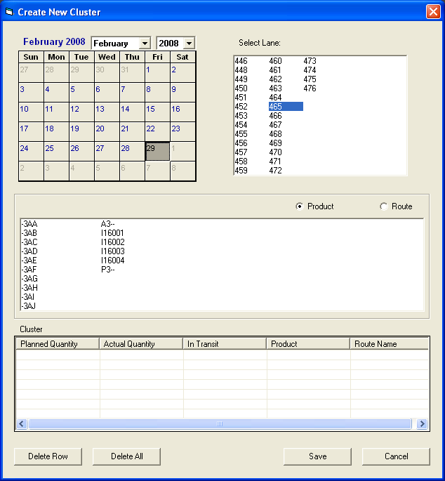

## 

## Adding Lane To Cluster:

To add a lane to a **Cluster**, the target **Cluster** should be selected first, than desired **Lane Handle** can be dragged and dropped straight onto the **Cluster Tag**.

# Setting Visual Product Attributes

## Selecting Products:

This OVHV functionality is there to help MR track inventory using visual attributes.

To attach a color to a **Product** select **Product** and **Color** from comboboxes below.



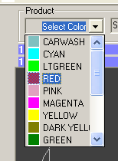 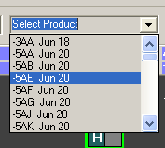

## Using Current Products Only checkbox:

When the CheckBox is checked ProductCombo will only list Current Products:

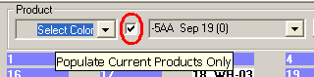

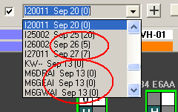 If today is September 13 then all **Products** with **Issue Date** **earlier** then today are not included in the **ComboBox.**

## Removing Selected Product Labels:

You can Remove Selected Product Label by selecting **Unassign Color** menu item from **Action** menu.

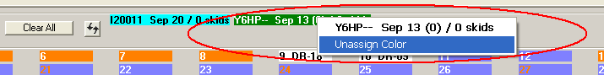

## Tracking Old Products:

Selecting **Highlight Old Products** from **Action** menu will instantly color all Old Products **Skids** RED.

**To undo this action select** Unhighlight Old Products **menu item.**

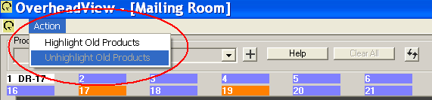

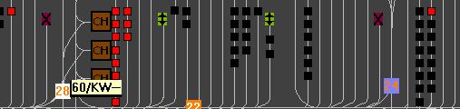

## Adding Products to Product Combo:

If Product is not in the Product Combo then press “ **+** “ button to select the required product from the list:



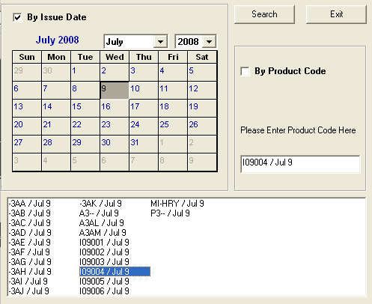

Search for **Product** by **Issue Date** or by **Product Code** and simply Double Click on it. The selected Product Code will be automatically added to a **Products** combo box, all you need to do just select a color from Colors combo box.

# Refresh the Screen button

Since OVHV is not automatically refreshed by MRS in All possible cases MR will need to synchronize OVHV manually from time to time. Pressing **Refresh** button will update all OVHV objects from MRS Data Storage.

